**RDT for Horus - Instruction Manual**

Thank you for choosing the RDT Telemetry Adapter.

The RDT is a telemetry interface for turbine ECUs and FRSKY radios running OpenTX, such as the Taranis X9, X9E, HORUS X10, X10S and 12S.

Please follow these instructions carefully to run your RDT properly and get maximum performance out of your system.

Note: In order to run the TD Widget script on the Horus, you must use OpenTX V2.2.x and above. If you have an older version, please upgrade your radio firmware version according to the following video example:

https://www.youtube.com/watch?v=JldMcQYoTDI

Once you have verified that you are running V2.2.x and above, please follow the following steps:

1. Copy the attached zipped folder (TD-RDT) and all its contents to your HORUS SD card. The easy way to do so without removing the card is connecting the Radio via a standard Mini USB Cable while the radio is ON to a standard USB plug on a computer ( The SD card should appear as a removeable drive within your explorer).
2. Copy the folder you received in the email (TD-RDT) into the WIDGETS folder in the SD card. The WIDGETS/TD-RDT folder should now look like this:  
   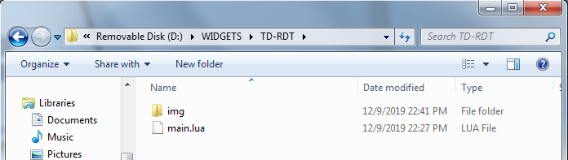
3. Eject the Horus from your PC and disconnect the USB cable.
4. Turn the Horus Off and turn it back On (power cycle).
5. Go to **TELEMETRY** Screen of your model.
6. Plug in your RDT to your ECU’s GSU port, and the other side (servo plug with only Red/Black wires) to the FRSKY Receiver S.Port. Note: S.Port connection - Black wire is Ground / Minus and Red wire is SIGNAL, not positive voltage.
7. Switch on the power to ECU and Rx.
8. On the Horus telemetry screen click “**Discover New Sensors**”.  
   You should now see some new sensors being displayed: RPM, A3, A4, Tmp1, Tmp2, Fuel etc.

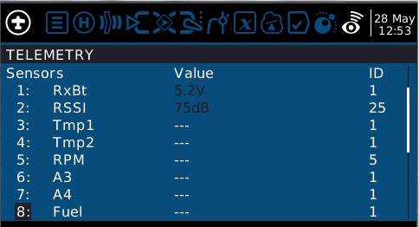

1. When completed, Click on Stop Discovering sensors.
2. Exit the Horus Telemetry of your model.
3. Back to the Main Screen, Select TELEM to add a WIDGET screen:

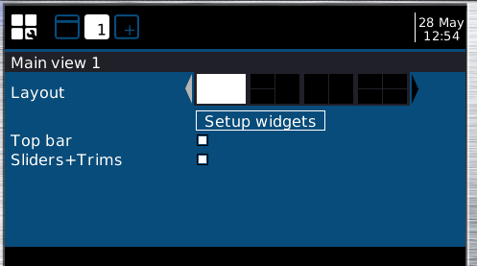

1. Choose Setup Widgets, Select Widget and choose the TD-RDT Widget. Remove top bar, trim tabs etc.  
   Note: Widget takes several seconds to load, so scroll slowly between widgets until you find TD-RDT widget.
2. After selecting the widget, go to Widget Settings, and set the following parameters according to your choice:

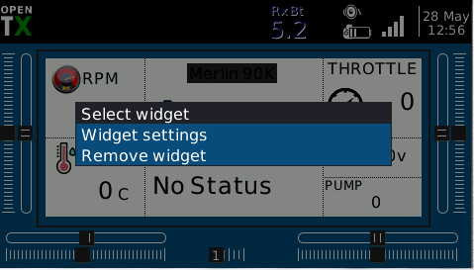

* 1. ECU type:
     1. 1 = Jetcat V6 and Jetcat V10
     2. 2 = Projet
     3. 3 = Xicoy V6 and Xicoy V10
     4. 4 = Kingtech G2 -G4
     5. 5 = Jetcentral SE
     6. 6 = Linton
     7. 7 = Swiwin
     8. 8 = Xicoy X Turbines
     9. 9 = Orbit (Evojet).

Note: if you need help in determining your ECU type please email [zavionixrc@gmail.com](mailto:zavionixrc@gmail.com) with a picture of your ECU.

* 1. Radio Stick Mode:
     1. 1 = Mode 1
     2. 2 = Mode 2
     3. 3 = Mode 3
     4. 4 = Mode 4

1. Set Fuel_Alarm for the amount of fuel you like the Alarm to be set.  
     
     
   Note: Fuel Alarm (fuel quantity < set fuel alarm value) triggers a global variable called GV9 in the radio, according to the following logic:  
   Fuel alarm not set – GV9 = 0.  
   Fuel Alarm set – GV9 = 1.  
     
   Note: GV9 can be used as a logical switch input to trigger fuel files, heptic alarm, beep or anything you require from the fuel alarm, in the following manner:  
   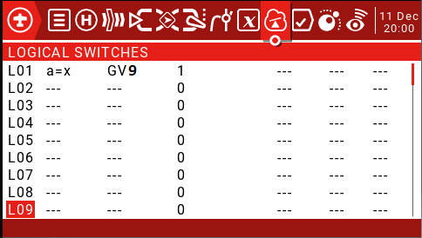

Using the above Logic Switch (L01) will trigger this switch when low fuel alarm is set.  
If you wish for example to get a periodic voice readout of the sound file “afu” every 5 seconds once fuel alarm is set, do the following:  
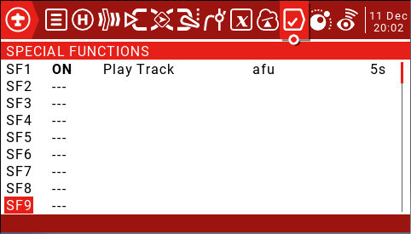

1. After setting the above, if you are using Jetcat (ECU Type 1) , Projet (ECU type 2) or Jetcentral SE (ECU Type 5) - skip to step 17.
2. For all other ECUs – run the fuel factor calibration sequence (**Appendix A**). this is not mandatory immediately and can be done at a later date.
3. Exit all menus.
4. Watch the real time Live Turbine Data in your radio and Enjoy.

For additional Questions, please feel free to email: [zavionixrc@gmail.com](mailto:zavionixrc@gmail.com)  
Many thanks go to T3chdad for his help developing the LUA 😊 – Please support him by visiting his website: http://t3chdad.com

Thanks and Fly Safe!

**Appendix A   
Fuel Calibration for ECU type Xicoy (3) and Kingtech (4).**

This appendix describes the required procedure to calibrate the accurate fuel consumption count, based on your fuel pump data in real time:

1. In the widget settings, set **Tank Size** to the amount of fuel your model fuel tank has. In our example lets assume 3000ml.
2. initial fuel factor is set to 100. This is a good starting point – this will be called **Old Fuel Factor**.
3. Fuel your model with a predefined amount of fuel – for this example lets assume 1 liter (1000ml). this will be called **actual fuel consumed**.
4. Start your turbine, Run the turbine in variable throttle settings (or fly your model) and shut the turbine off after the pre defined amount of fuel has depleted.
5. Write down the amount of fuel which the RDT reports as left in your tank after depleting 1000ml of fuel. In our example lets assume the RDT displays 1200ml left in the tank. This will be called **Fuel left in tank.**
6. Calculate the **new fuel factor** according to the following formula:  
     
   **New fuel factor** = **actual fuel consumed** / (**total fue**l – **fuel left in tank**) * **Old Fuel Factor**  
     
   In our example:  
   **New Fuel factor** = 1000 / (3000 – 1200) * 1000 = 555
7. Input the **New Fuel factor** (now calibrated) value into widget setting -> Fuel Factor, and go to step 15 in the manual.